1-Test Planning
CH5 Part1 - start at 2:16

1.1-Purpose and Content of a Test Plan
CH5 Part1 - start at 2:16
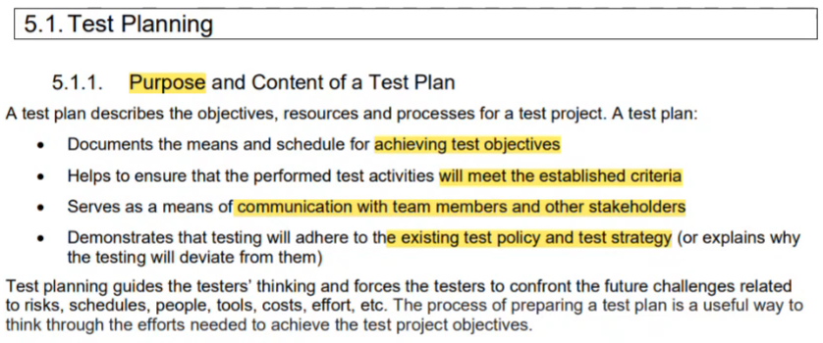
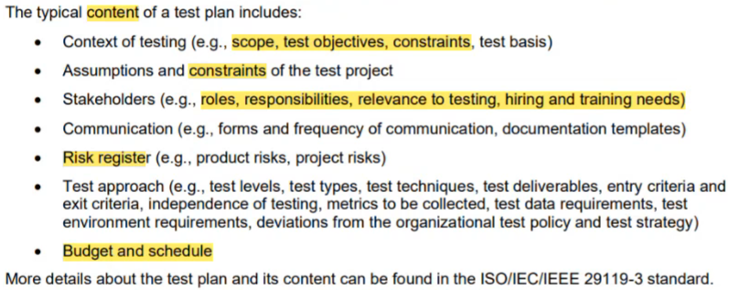

1.2-Tester's Contribution to Iteration and Release Planning
CH5 Part1 - start at 11:11
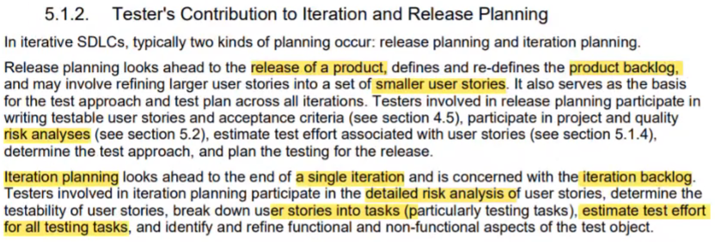

1.3- Entry Criteria and Exit Criteria
CH5 Part1 - start at 15:46
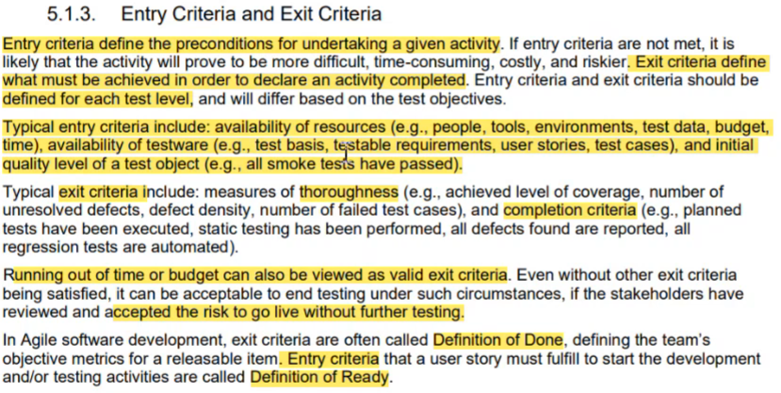

1.4-Estimation Techniques
CH5 Part1 - start at 23:25
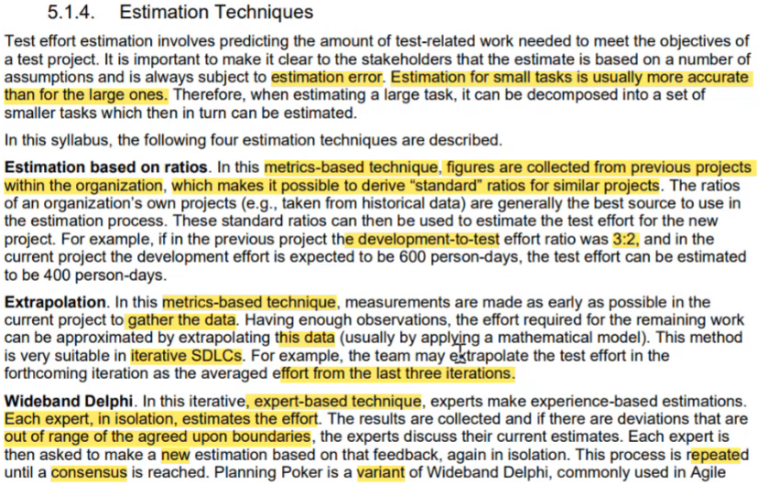
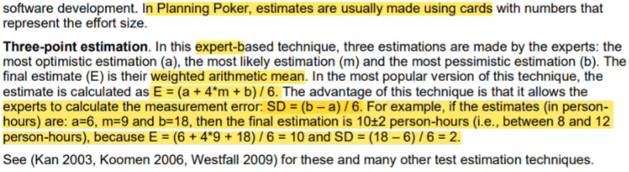

1.5-Test Case Prioritization
CH5 Part1 - start at 38:05
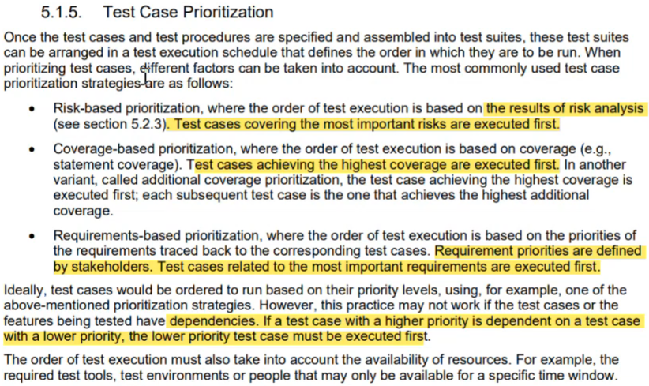

1.6- Test Pyramid
CH5 Part1 - start at 42:28
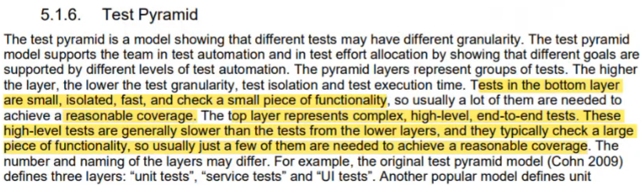

1.7- Testing Quadrants
CH5 Part1 - start at 44:10
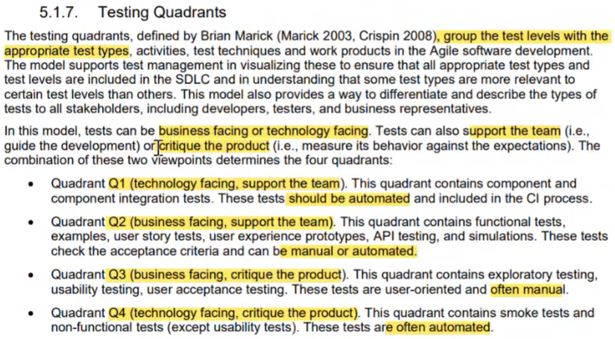

Testing Quadrants Summary
CH5 Part1 - start at 52:00
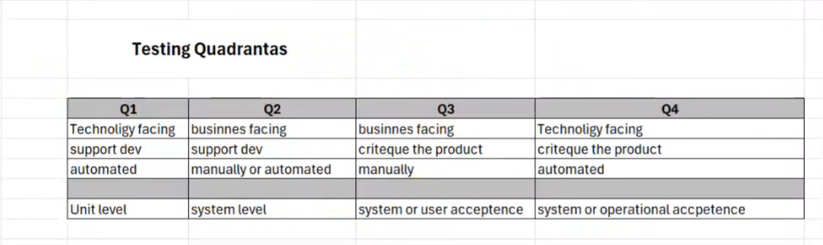

2-Risk Management
CH5 part2 _ CH6 - start at 0:09
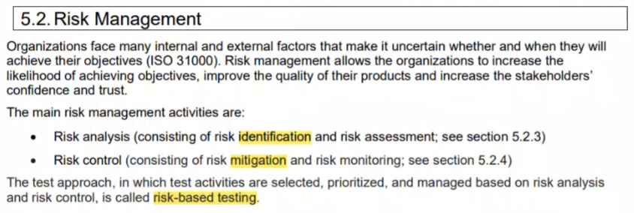
5-2-CH5 part2 _ CH6 - start at 0:09

2.1-Risk Definition and Risk Attributes
CH5 part2 _ CH6 - start at 0:09
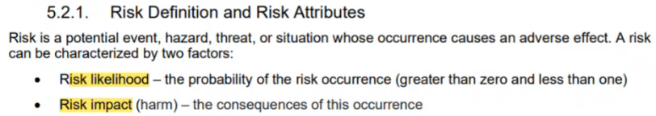

2.2-Product Risk Analysis
CH5 part2 _ CH6 - start at 2:21
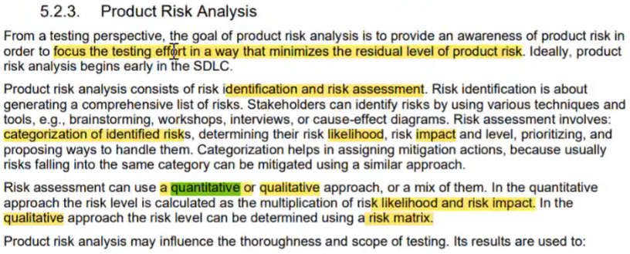
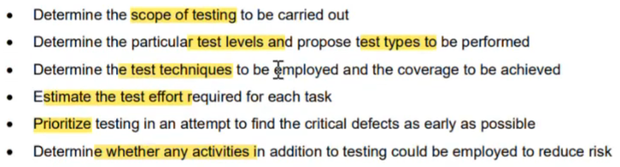

2.3-Project Risks and Product Risks
5-2-CH5 part2 _ CH6 - start at 3:59
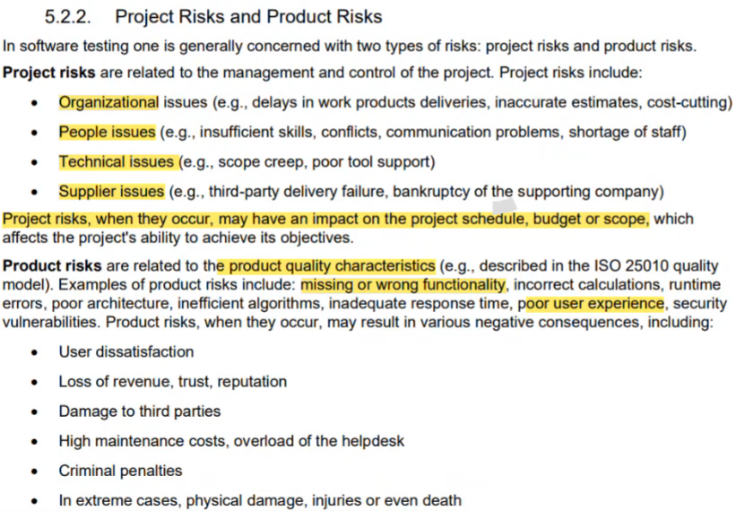

2.4-Product Risk Control
5-2-CH5 part2 _ CH6 - start at 13:12
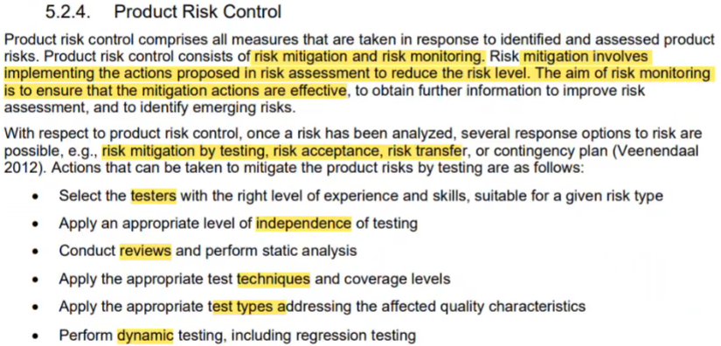

3- Test Monitoring, Test Control and Test Completion
5-2-CH5 part2 _ CH6 - start at 17:29
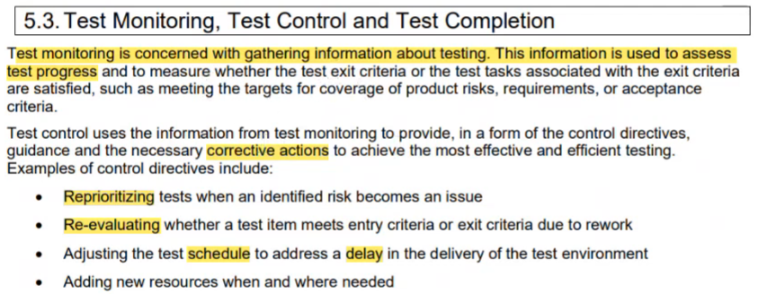
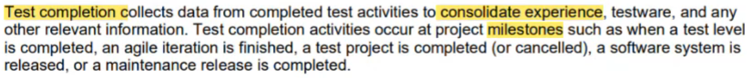

3.1-Metrics used in Testing
5-2-CH5 part2 _ CH6 - start at 21:05
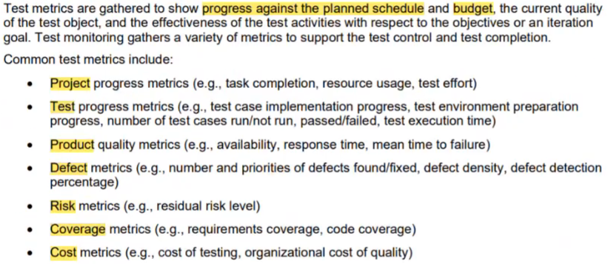

3.2-Purpose, Content and Audience for Test Reports
5-2-CH5 part2 _ CH6 - start at 28:05
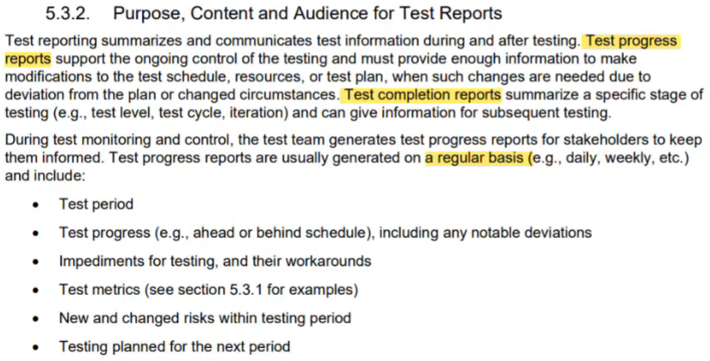
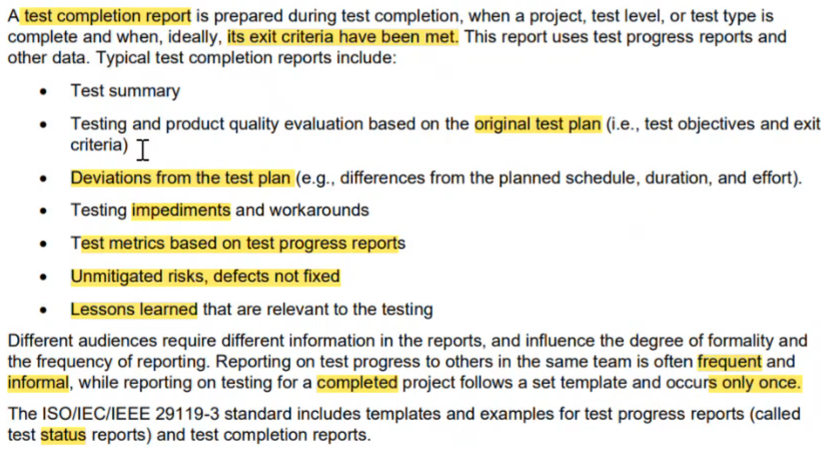

3.3-Communicating the Status of Testing
5-2-CH5 part2 _ CH6 - start at 34:30
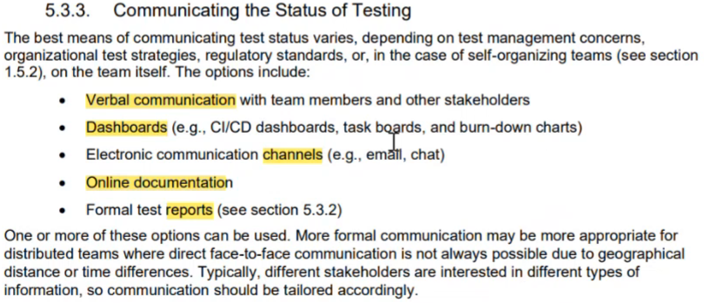

4-Configuration Management
5-2-CH5 part2 _ CH6 - start at 35:47
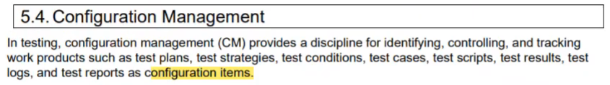
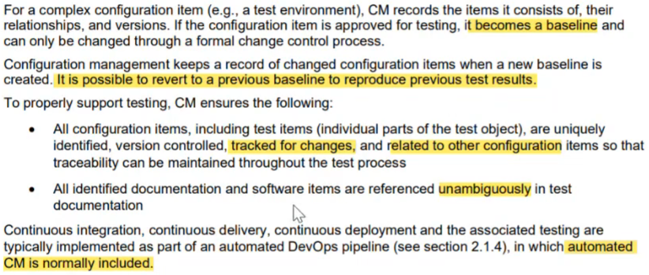

5- Defect Management
5-2-CH5 part2 _ CH6 - start at 39:23
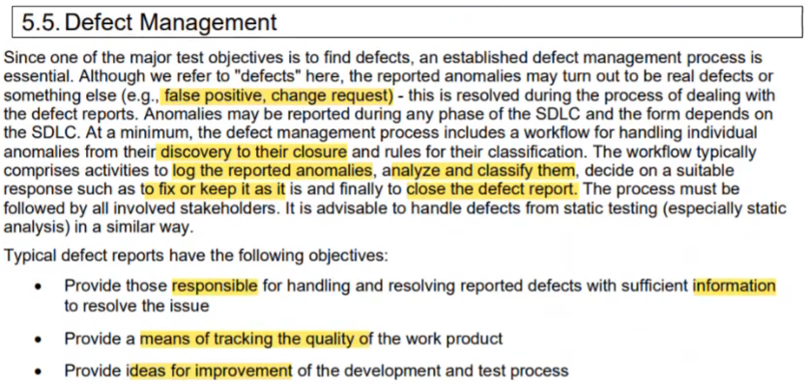
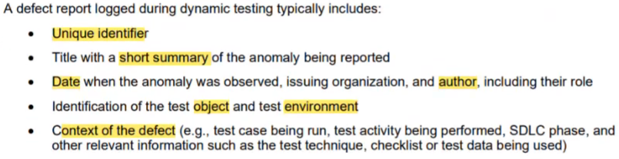
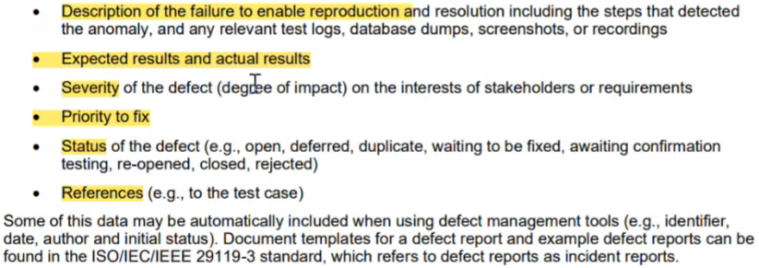

6-Tool Support for Testing
5-2-CH5 part2 _ CH6 - start at 48:02
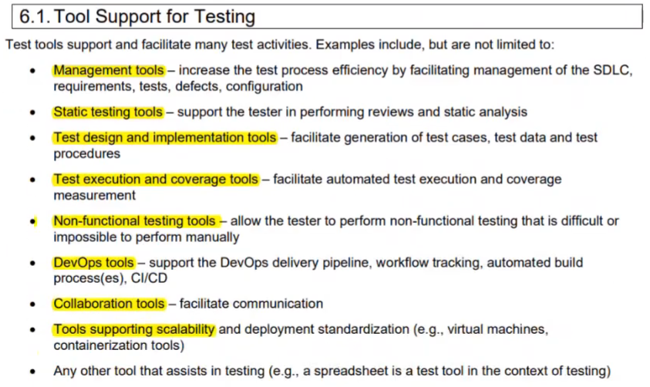

7-Benefits and Risks of Test Automation
5-2-CH5 part2 _ CH6 - start at 50:35
